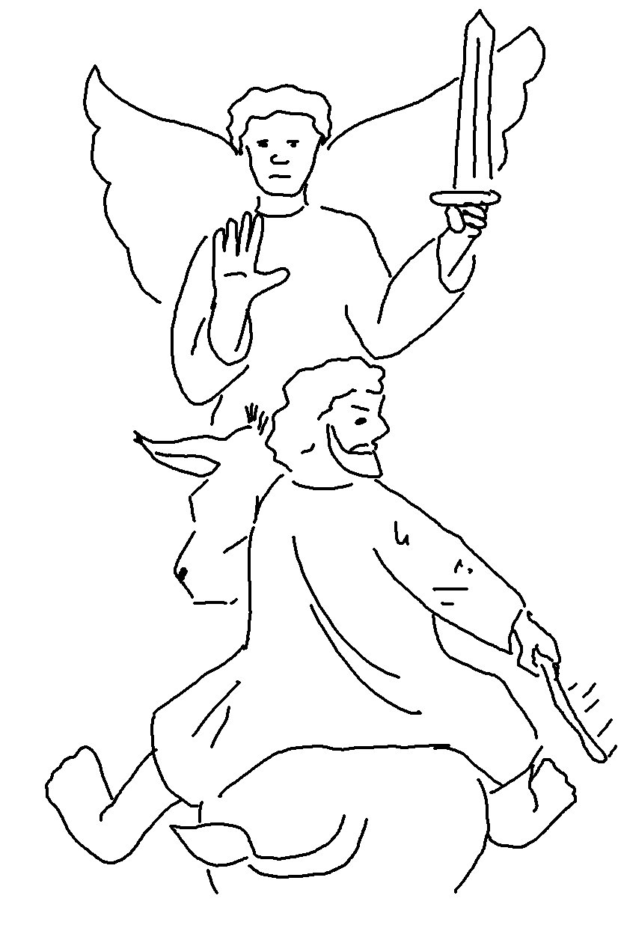
Choose a
good reputation over great riches.
Proverbs 22:1_{NLT}

